Reading motivation

Inhoud
Prologue 2
Reading in numbers 3
Definition of the problem 4
Online reading skills 5
Examples of reading motivation in the classroom 6
Calligrams 6
Tableaux vivant 6
Tablet Tales 7
Dice game 7
Multi role 7
Reading program at NMS Voitsberg 7
Google Lit trip 8
Choose your own story 8

Prologue

During the Erasmus+ project in Belgium we worked on reading motivation. Before we can go into to the different techniques we used in our classes, we have to go into reading skills.
We agreed on the following definition of reading skills, used by the Programme for International Student Assessment (PISA):
‘Understanding, using, reflecting on and dealing with written texts in order to achieve personal goals, develop ones knowledge and capacities and to participate in society.
PISA examines to what extent adolescents are able to understand and integrate texts they are confronted with in their everyday lives. Aspects such as reading speed take a back seat here. PISA measures the following dimensions:
Retrieve texts and access them
Interpret and integrate texts
Reflect and evaluate texts
The texts used in PISA can be classified by means of four characteristics:
Type of medium (paper or electronic)
Text format
Prose/continuous text (Tales, commentary, apostilles…)
Non-continuous texts (Forms, manuals, graphs, maps…)
Hybrid forms and multiple texts: in everyday life, several texts have to be read simultaneously which stem from different sources and are set in different formats
Text type (e.g. description, narrative, essay, argumentation or instruction)
For electronic texts: Context (written by an author or message-based, such as online forums, blogs etc.)
(source: https://www.pisa.tum.de/en/domains/reading-literacy/)

Reading in numbers

According to Ghesquière (Study 1993) 39% of the 9/10 year olds reads at least on book each week. With 11/12 year olds this percentage drops to 23%. This is confirmed in a study by Clark and Rumbold (2006) which states the number of children who do not read for pleasure is growing.
In 2008 (Clark and Osborne), 2010 (Topping) and 2011 (Douglas) several studies reconfirmed this statement. Children are enjoying reading less as they get older.
When you ask children now about their favourite hobby, 44% of the 9 year olds say it’s reading a book. In the group of 12 year olds this is 33%. (Coillie, 2014)
As you can see, the number has gone up. The use of new media is inversely proportional with the reading of books.
Figure 1 - PISA, 2012: Reading Skills
The 2012 Pisa skills study shows that in some countries there is a serious gap between high and low achievers and frequent online readers have higher reading skills in general.
Next to the frequency, studies also show that “liking to read” also has a positive relationship with attainment, text comprehension and grammar. It also increases the general knowledge of the reader.
(sources: Clark and Douglas, 2011; Clark, 2011; Clark and Rumbold, 2006)

Definition of the problem

We all read more than previous generations, but…
- Stronger book reading culture in large language communities
- High scores for technical reading do not correlate with reading motivation
- Young people:
  - traditional reading losing ground
  - non-linear reading taking over
- Reading education – problems with …
  - book lists
  - analytical approach
  - focus on technical reading skills
In their study of 2011 Clark and Douglas state: “Text messages, magazines, websites and emails have been found to be the most common reading choices for young people.”
This means young people focus on digital reading skills rather than the traditional ones.
In 2014, the study of Bakker says we read less books, but we read more online. That’s just looking at quantity. If we turn the page to quality, we see digital media focusing on non-linear reading and multitasking. The interpretation process falters and we use less concentration, less interpretation and less contemplation. The medium, however, makes the experience. (e.g. E-reader, laptop, tablet, smart phone, …)
The differences between printed and digital information lie in:

Printed
- Linear reading
- Single text
- Textual
- Static
- One dimensional
- One Author

Digital
- Non-linear reading (links)
- Connected texts
- Multimedial
- Flexible
- Changing texts
- Interactive
- Can be multiple authors

Online reading skills

The implementation of online literacy brings some new skills to the original definition we made. According to Clemens (2014) we have to add the following skills:
- Scan the texts
- Ask yourself questions
- Select hyperlinks
- Assess information
- Construct your own texts
In the same study Clemens talks about the need for contextual change. We need to rethink the concept of literacy, redefine the curricula and attainment targets, update learning materials, bring in media literacy and enhance the focus on higher-order thinking.

Examples of reading motivation in the classroom

Calligrams

A calligram is a text visually arranged in a way that it forms an image associated with the text's contents. It can be a poem, a phrase, or a single word; the visual arrangement can rely on certain use of the typeface, calligraphy or handwriting, for instance along non-parallel and curved text lines, or in shaped paragraphs. The image created by the words illustrates the text by expressing visually what it says, or something closely associated; it can also, on purpose, show something contradictory with the text or otherwise misleading.
In this exercise we asked students to transform an existing poem into a calligram.
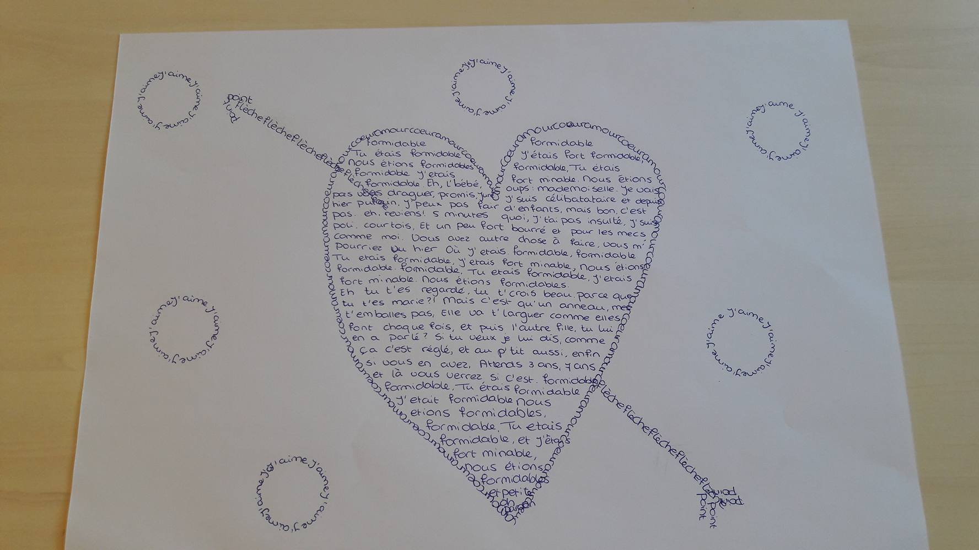

Video link: https://www.youtube.com/watch?v=hKH_syOip0E

Tableaux vivant

A tableau, French for 'living picture', is a static scene containing one or more actors or models. They are stationary and silent, usually in costume, carefully posed, with props and/or scenery, and may be theatrically lit. It thus combines aspects of theatre and the visual arts.
A tableau may either be 'performed' live, or depicted in painting, photography and sculpture, such as in many works of the Romantic, Aesthetic, Symbolist, Pre-Raphaelite, and Art Nouveau movements.
In the late 19th and early 20th centuries, tableaux sometimes featured poses plastiques ('flexible poses') by virtually nude models, providing a form of erotic entertainment, both on stage and in print.
Tableaux continue to the present day in the form of living statues, street performers who busk by posing in costume.
After reading a book, you can have your class recreate the story in tableaux vivant.

Tablet Tales

Tablet Tales lets you read a book on a tablet. Inside the book there are several hyperlinks. These hyperlinks give more info, pictures, extensions, …
More info can be found here: http://www.aidanchambers.co.uk/ipadapp.htm

Dice game

Video link: https://www.youtube.com/watch?v=tFiJyYkje9I

Multi role

Link to ppt: http://ka2sevencountries.altervista.org/wp-content/uploads/2017/10/Presentazione-standard1.pptx
Video link: https://www.youtube.com/watch?v=8BT_naUOfWg

Reading program at NMS Voitsberg

At our school we have a project to improve the reading skills of our students. Our pupils are at the age of 10 to 14.
After the 20 minutes break at 10.15 where the pupils have their break outdoors to get some movement there is a time of 15 minutes where the pupils have to read. They are allowed to read what they are interested in. The weaker pupils may also read comics.
Normally the pupils bring their own books but there are also books in class or they get the books from the school library.
For the pupils whose reading skills are very weak we have so called “reading coaches”. These are students whose reading skills and reading comprehension is very good. They help the weaker readers with the reading, who read the text aloud and the good students make sure that they understand what they have read. These students go out of the class and find another place at the school house (e.g. the corridor where there are desks or the library etc.) so that they don’t disturb the other ones.
For the weaker pupils there are also short texts where they have to do true or false exercises or to answer questions. So the pupils have to read the texts very carefully and the teacher can see if the pupils understood the text or not.
This reading time takes place every day. So there is a time of concentrated reading for each student of 75 minutes a week to improve their reading skills.

Google Lit trip

Google Lit Trips are free downloadable files that mark the journeys of characters from famous literature on the surface of Google Earth. At each location along the journey there are placemarks with pop-up windows containing a variety of resources including relevant media, thought provoking discussion starters, and links to supplementary information about “real world” references made in that particular portion of the story.
Video link: https://www.youtube.com/watch?time_continue=22&v=dkaQztcVWEA

Choose your own story

ChooseYourStory.com is a community-driven website centered on Choose-Your-Own-Adventure style storygames. Members create their own storygames, read and comment on other members’ storygames, participate in the forum, and improve their writing ability.
Visit their website for some fun reading experience.

